February 9th – March 24th, 2018
CALL FOR ENTRY
About the Exhibition
The Winter Festival Art Show & Sale is the premier art event of northern Saskatchewan. In this exhibition hundreds of artworks by emerging and professional artists from across the province are shown at the Mann Art Gallery. Each year, a guest arts professional curates the exhibition and designates awards that are sponsored by local businesses and organizations. The exhibition is unveiled and awards are presented at an opening gala reception, followed the next day by an in-depth curatorial talk and walkthrough. Now entering its 42nd year, the Winter Festival exhibition is a well-regarded tradition that reflects an incredible level of artistic production in our community.
The Process
All Saskatchewan artists who are members of the Mann Art Gallery are invited to participate in this exhibition. (See Eligibility and Entry Instructions for details.) The artwork is dropped off at the gallery in late January. Over the subsequent two weeks, artworks are curated into our three gallery spaces by an independent guest curator. Past curators include Sandra Fraser, Grant McConnell, and Zachari Logan. Everyone who enters is guaranteed inclusion, so long as the artworks have been created within the last two years, have not been previously exhibited at the Mann Art Gallery, follow the size and hanging hardware guidelines.
Important Dates
Artwork Drop-off  Sunday January 28th and Monday January 29th, 2018  1 1:00 PM – 5:00 PM | Opening Gala Reception  Friday February 9th 2018, 7:00 PM  Reception Admission: Participating Artists – FREE  Gallery Members - $10.00; General Public - $15.00
Guest Curator’s Talk & Walkthrough Tour  Saturday February 10th 2018  10:00 AM - 1:00 PM | Artwork Pick-up Date  Sunday March 25th and Monday March 26th, 2018  1:00 – 5:00 PM

2018 Winter Festival Guest Curator:
Carole Epp

Darrell Bell has over 31 years experience as an artist and gallery owner in Saskatoon. Darrell graduated with a degree in fine

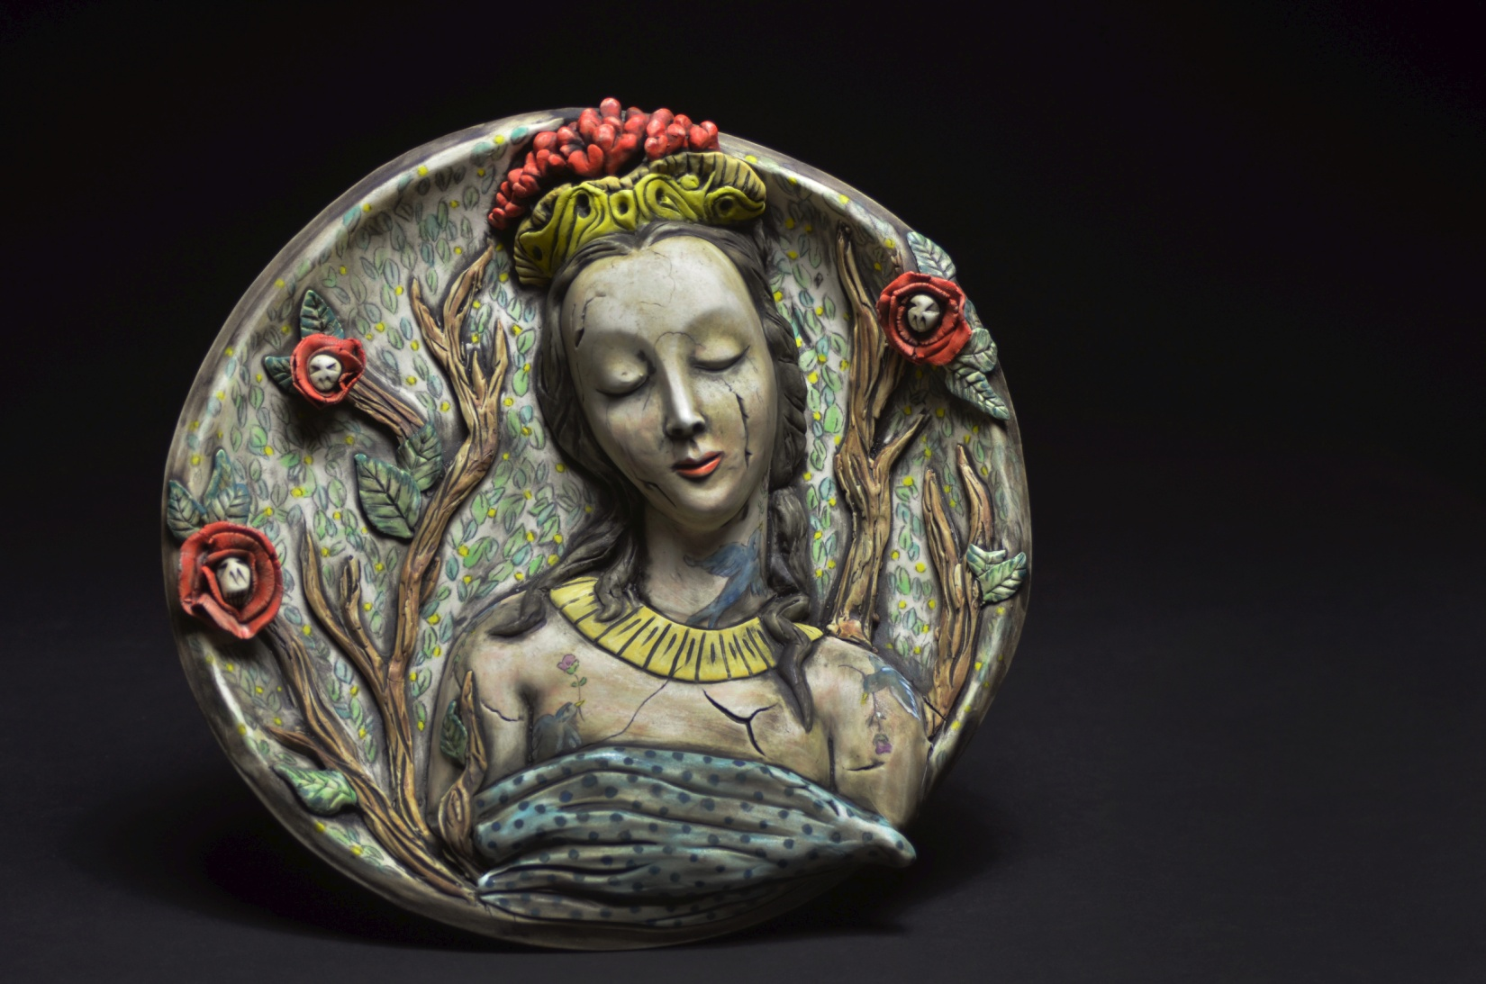
Image: Carole Epp, Things Fall Apart, 2017, cone 6 clay, underglaze, and cold finish, 11 x 11 x 2.5”
Twenty years after taking my first ceramics class in college I’m still just as compelled and excited by this material as I was back then. Working in ceramics has allowed me to travel internationally to meet and work with some of the most inspiring creative minds out there. Back in 2005 I obtained my graduate degree from the Australian National University. I currently live in Saskatoon, Saskatchewan working in a home-based studio creating both functional objects and a line of figurative sculpture. Due to workaholic tendencies and a passion for community, I’ve been the editor of Musing About Mud (www.musingaboutmud.com) for over ten years, have brought together groups like Make and Do ceramics (www.makeanddo.ca) to highlight the wealth of creative ceramics here in Canada, traveled to teach workshops, give talks, exhibit work, and basically don’t say no to anything clay related that is worth promoting and getting involved with. All of which makes me happier than I ever imagined.
- Carole Epp, 2017
View Carole’s work and more at her website: www.caroleepp.com
Eligibility & Entry Instructions
- Artists must be 18 years of age or older and must reside in Saskatchewan.
- All Artists MUST be members of the Mann Art Gallery for the 2018 year. Membership forms will be available at the Mann Art Gallery on the drop-off dates. Rates are $15.00/student, senior; $20.00/individual; $35.00/family.
- Artists can submit a maximum of two artworks.
- Artworks must be completed within the last two years and not previously exhibited at the Mann Art Gallery.
- Entries will be the artist’s original design (no copies, reproductions, or commercial kits).
- Artworks must be ready for installation. This includes having proper hanging hardware, as per the following point. Frail or excessively heavy or poorly prepared works will not be included in the exhibition.
- D-Rings (Fig. 1) must be attached to all two-dimensional pieces for the safety of the artwork and for proper installation. (Note that metal frames do not typically have D-Rings, but appropriate hangers are shown in Fig. 1, below). D-Rings can be found at most local hardware stores, Hues Art Supplies (Saskatoon), Art Placement (Saskatoon), Michael’s Craft Stores, and online at www.leevalley.com (item numbers 00F.13.10, 00F13.12, 00F13.20, and 00F13.22).
- Wire/string will not be accepted as a means to hang (Fig. 2). There are no exceptions to this rule.
- Hanging hardware is to be measured equal distances from the top of the frame to the D-Rings on the right and left side of the piece (Fig. 3).
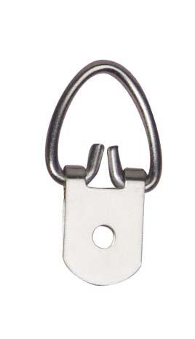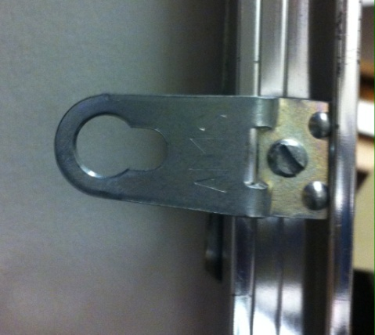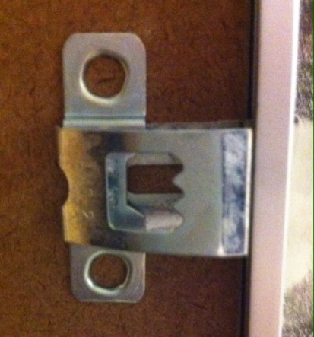
Fig. 1: Examples of D-Ring (left) and appropriate metal frame hangers.
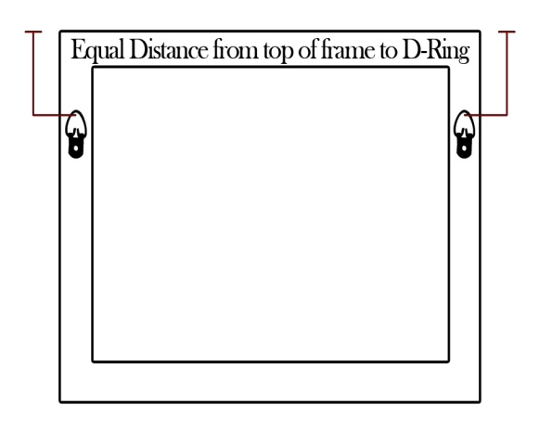
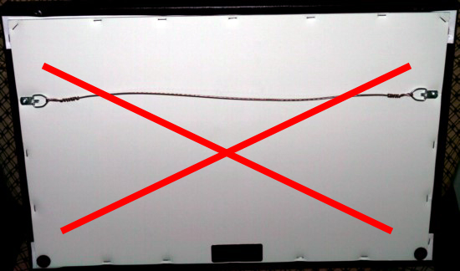

Fig. 2: No picture hanging wire allowed Fig. 3: Example of D-Ring/hanging hardware Location

- The Gallery reserves the right to not exhibit works that exceed 4 x 4’ in the interest of space limitations.
- Each entry of artwork must have attached on the verso: the artist’s name, title, date, size, medium, and sale price. Please also note if plexiglass (rather than glass) is used in framed works. The Gallery will need to use the correct cleaning agent to avoid scratching and damaging plexiglass.
- All artwork entries must be delivered and unpacked in person by the artist or their representative to the Mann Art Gallery on the drop-off dates of January 28th and 29th, 2018 between 1:00 and 5:00 PM. Entries shipped by mail or courier will not be accepted. The name and phone number of either the artist or representative must be listed on the entry form.
- The Gallery does not have space to store packing materials. These must be taken away after artwork drop-off. Any materials left at the gallery will be disposed.
- Due to inquiries of CARFAC exhibition fees by previous applicants to the Winter Festival, the Mann Art Gallery Board of Directors in consultation with CARFAC has established that ALL ENTRIES MUST BE FOR SALE, overruling the gallery’s obligation to pay these fees. If the Mann Art Gallery were required to pay fees, this exhibition would cost over $60,000.000 and would not be financially feasible. The gallery takes a 30% commission on works sold during the exhibition. If you have any questions or concerns regarding this declaration, please contact the Mann Art Gallery.
- Exceptions to these rules will not be accepted.
DROP-OFF DATES

Sunday January 28th and Monday January 29th, 2018 | 1:00 PM – 5:00 PM
Entries will not be accepted after 5:00 PM on Monday January 29th 2018

PICK-UP DATES
Sunday March 25th and Monday March 26th, 2018 | 1:00 PM – 5:00 PM
Unsold artworks must be picked up by 5:00 PM on Monday March 26th or they will be disposed of at the discretion of the Gallery. If, for extraordinary reasons, you cannot pick the work up on these days, you may call the Gallery no later than Friday March 17th to request a temporary extension.
NOTE: Only under extenuating circumstances will we grant such an extension

Please contact the Mann Art Gallery if you have any questions or concerns:
The Mann Art Gallery  142 – 12th Street West  Prince Albert, SK  S6V 3B5 | [p] (306) 763-7080  [f] (306) 763-7838  [e] info@mannartgallery.ca  [w] www.mannartgallery.ca
The Winter Festival Exhibition is possible thanks to support from the Mann Art Gallery’s funders:

